Annex 2

[PROJECT ANALYSIS/ DESIGN]

PROJECT TITLE: RI.UVT.RO Redesign
COMPANY: Universitatea de Vest Timișoara - DRI
COMPANY COORDINATOR: Alexandru Nagy, iosif.nagy04@e-uvt.ro
TEAM LEADER: Marko Bele, marko.bele05@e-uvt.ro
TEAM MEMBERS: Yashfen Al, yashfen.al10@e-uvt.ro, Nour Shahin, nour.shahin10@e-uvt.ro, Constantin Benec, constantin.benec04@e-uvt.ro, Shoaib Ahmed, shaoib.ahmed10@e-uvt.ro, Cătălin Dumitru, catalin.dumitru05@e-uvt.ro, Luca Bozdog, luca.bozdog03@e-uvt.ro, Abousher Aisha, abousher.aisha10@e-uvt.ro
DATE: 05.05.2026

1. PROJECT CONTEXT [MAX 1/2 PAGE]
The current DRI website suffers from poor information structure, broken links, duplicated content (especially Erasmus sections), and heavy reliance on downloadable documents (PDF, DOCX) instead of structured web pages.
Users (students, staff, and partner institutions) struggle to find relevant information quickly due to unclear navigation, inconsistent page hierarchy, and weak internal linking.
The system is needed to:
- Provide clear user journeys for different audiences (incoming/outgoing students, staff, partners)
- Replace document-based navigation with structured web content
- Ensure maintainability through a modern CMS architecture
- Deliver a responsive, accessible, and scalable web platform

2. OBJECTIVES [MAX. 5 BULLETS]
- Design and implement a clear information architecture with structured navigation
- Develop a headless CMS system using WordPress + React
- Replace document-heavy flows with structured HTML pages
- Ensure responsive, accessible, and performant frontend experience
- Deliver a maintainable and scalable platform for future expansion

3. FUNCTIONAL REQUIREMENTS [CLEAR LIST ONLY]
- FR1 - Users can navigate structured sections (Erasmus, Programmes, Partnerships, etc.)
- FR2 - Users can view dynamic content fetched from WordPress via REST API
- FR3 - Administrators can create and manage content via WordPress CMS
- FR4 - System supports multiple content types (Pages, Posts, Custom Post Types)
Optional:
- NFR1 - The system must load pages under 2 seconds (performance)
- NFR2 - The system must follow accessibility standards (WCAG basic compliance)

4. CORE USE CASES [MAX. 3]

Use Case 1 - View Programme Information
Actor: Student
Steps:
- Access website homepage
- Navigate to “Programmes” section
- Select a programme
- View structured information (requirements, deadlines, steps)

Use Case 2 - Access Erasmus Application Flow
Actor: Student
Steps:
- Navigate to “Erasmus” section
- Select incoming or outgoing path
- Follow structured steps (eligibility → documents → deadlines)
- Access contact information

Use Case 3 - Manage Content
Actor: Administrator
Steps:
- Log in to WordPress admin panel
- Create or edit content (page/post/custom type)
- Publish content
- Content becomes available via API in frontend

5. DRAFT ARCHITECTURE [1 DIAGRAM + 5 LINES EXPLANATION]
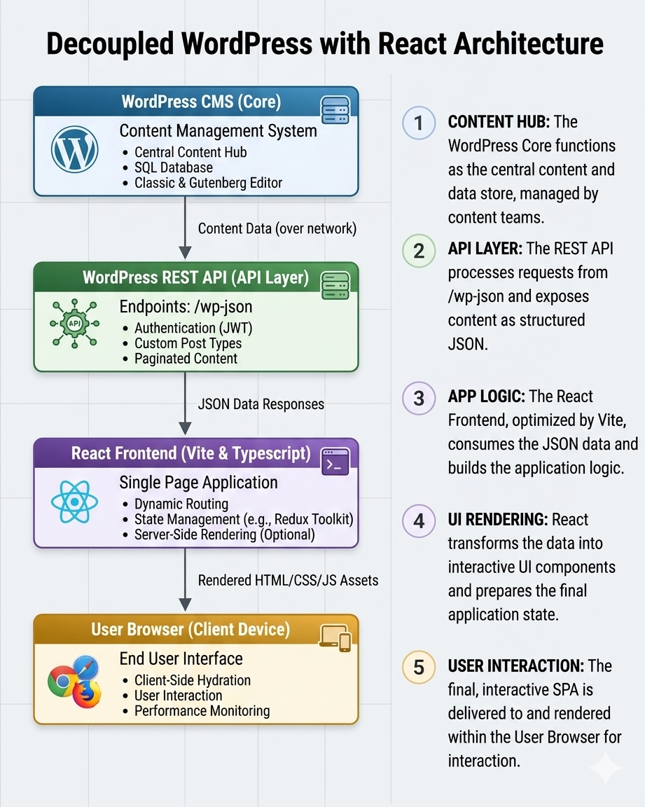
Short explanation:
- WordPress manages all content and structure
- REST API exposes content as JSON
- React fetches and renders dynamic pages
- Users interact only with the React frontend

6. INITIAL GANTT

Week | Goal
1 | Audit existing website, identify issues
2 | Define sitemap and user flows
3 | Design system and frontend architecture
4 | Setup Wordpress + React environments
5 | Implement content structures
6 | Build frontend pages and integrate API
7 | Testing, UX improvements, bug fixing
8 | Final QA, optimization, documentation

7. MAIN RISKS [MAX. 3]

Risk | Mitigation
API integration issues between Wordpress and React | Early testing of endpoints and data structure
Poor content structure affecting frontend | Strict definition of content types and fields
Performance issues due to large content or assets | Optimize images and implement efficient data fetching

Team Leader

Bele_Marko________________________________ 05.05.2026________

